

DEPARTMENT OF B.VOC SOFTWARE DEVELOPMENT

ASUTOSH COLLEGE, KOLKATA

Academic Year 2017-2018



Integrated Hybrid Learning Earning Management System

|  |  |
| --- | --- |
| Under Supervision Of  *Prof. Abhishek Barman* | Submitted By:  *Shirshendu Halder(01)*  *Sujay Bakchi(04)*  *Soumitra Patra(21) Sumanjit Banerjee(22)*  *Swarup Das(23)* |



Integrated Hybrid Learning Earning Management System

By

Shirshendu Halder, Sujay Bakchi, Soumitra Patra,

Sumanjit Banerjee and swarup das

Under Guidance of

Prof. Avishek Barman,

Professor of

*Dept. B.voc (Software development)*

A Final Year Project Report Submitted to the graduate faculty

In partial fulfillment of the requirement for the degree of

BACHLOR OF VOCATIONAL (*Software Development*)

B.Voc: Software Development

Batch of 2015-2018

Asutosh college second campus

Bhasa, Bishnupur, South 24Pgs

**Table of Contents**

**LIST OF ABBREVIATIONS…..……………………………………………..1**

**ACKNOWLEDGEMENT…………………….…………………………….…3**

**ABSTRUCT…………………………………………………………………….4**

**CHAPTER -1 Overview…………………………………………………….5**

* 1. Introduction...............................................................................5
  2. E-Learning……………………………………………………………….5
     1. Why eLearning………………………………………....8
     2. E-learning Scope in India……………………………..9
     3. History of eLearning………………………………….10

1.3 Motivation…….............................................................................12

1.4 What our project does..................................................................12

**CHAPTER-2 Analysis Document…………………………………….…13**

2.1 Introduction to SDLC……………………………………………………..13

2.2 SDLC………………………………………………………………………..13

2.3 SDLC Models………………………………………………………………14

2.4 Prototype Model…………………………………………………………..17

2.4.1 When to use Prototype model……………………………18

2.4.2 Advantages of prototype Model………………………….19

3.4.3 Disadvantages of prototype Model ……………………..19

3.4.4 Application of prototype Model……………………….…19

2.5 Design Documents ………………………………………………………21

2.5.1 Use Case Diagram…………………………………………21

2.5.2 Data Flow Diagram………………………………………..23

2.5.2.1 LEVEL-0 or Context level Diagram…….23

2.5.2.2 LEVEL-1 Diagram………………………..24

2.5.2.3 LEVEL-2 Diagram………………………..26

**CHAPTER-3 Tools and Environment…………………………………28**

3.1 Tools / Platforms: ………………………………………………………..28

3.1.1 Front end……………………………………………………28

3.1.2 Back end…………………………………………………….28

3.1.3 Hardware Requirements…………………………………..28

3.2 Hardware Environment………………………………………………….28

3.3 Software Environment …………………………………………………..29

3.3.1 Xampp……………………………………………………….29

3.3.2 Sublime text…………………………………………………29

3.3.3 Chrome……………………………………………………...29

3.3.4 Git……………………………………………………………30

3.3.5 Github……………………………………………………….30

3.4 Language used……………………………………………………..........31

3.4.1 HTML…………………………………………………………31

3.4.2 CSS………………………………………………………..…31

3.4.3 Bootstrap…………………………………………………….32

3.4.4 Jquery………………………………………………………..32

3.4.5 Introduction to PHP……………………………………..…33

3.4.6 Why RDBMS?.............................................................33

3.4.7 Introduction to MySQL……………………………….……33

**CHAPTER-4 Database Design……………………………………….…35**

4.1 Introduction……………………………………………………………….35

4.2 Entity……………………………………………………………………..…36

4.3 Attribute……………………………………………………………………36

4.4 Relationship………………………………………………………….……37

4.5 Normalization………………………………………………………….…38

4.5.1 1NF (First normal form) ………………………………..…38

4.5.2 2NF (Second normal form) ………………………………39

4.5.3 4NF (Boyce-coded normal form)…………………………39

4.5.4 3NF (Third normal form)……………………………….…40

4.6 ERD & DB implementation………………………………………………41

**CHAPTER 5-TESTING……………………………………………………..42**

5.1 Introduction ………………………………………………………………42

5.1.1 Purpose of testing software……………………………….43

5.1.2 A test Plan must contain the following…………………..43

5.2 Testing Methods Used For Project………………………………………43

5.2.1 Correctness testing…………………………………………43

5.2.2 Black-box testing…………………………………………..44

5.2.3 White-box testing…………………………………………..44

5.2.4 Performance testing………………………………………..45

5.2.5 Reliability testing …………………………………………...45

5.2.6 Security testing……………………………………………...46

5.3 Demonstration……………………………………………………………47

5.3.1 Home page………………………………………………….47

5.3.2 library………………………………………………………..49

5.3.3 Login…………………………………………………………50

5.3.4 Signup………………………………………………………..51

5.3.5 Employee area………………………………………………52

**CHAPTER-4 Development……………………………………………….57**

4.1 Total project time……………………………………………………..57

**CHAPTER 7-CONCLUSION………………………………………………58**

**REFERANCES**

**LIST OF ABBREVIATIONS**

IHLEMS - Integrated Hybrid Learning Earning Management System

LMS - Learning Management System

E-learning – Electronic learning

M-learning – Mobile Learning

CBT - Computer-Based Training

IBT - Internet Based Training

WBT - Web Based Training

CAI - Computer Assisted Instruction

PLATO - Programmed Logic for Automatic Teaching Operation

PDAs - Personal Digital Assistants

HTML –Hyper Text Markup Language

CSS –Cascading Style Sheet

XAMPP – Cross Apache MySQL PHP Perl

WWW – World Wide Web

RAM – Random Access Memory

HDD –Hard Disk Drive

DVD – Digital Virtual Disk

GHz – Gigahertz

OS – Operating System

TB – Terra Byte

GB – Giga Byte

PHP - PHP Hypertext Preprocessor

OOP-Object Oriented Programming

SQL – Structured Query Language

RDBMS - Relational Database Management Systems

SDLC - Software Development Life Cycle

BRS - Business Requirement Specification

ER – Entity Relationship

1NF – First Normal Form

2NF – Second Normal Form

3NF – Third Normal Form

BCNF – Boyce Coded Normal Form

API – Application Programming Interface

SCM – Source Code Management

W3C –World Wide Web Consortium

**ACKNOWLEDGEMENT**

We are pleased to acknowledge Prof. Abhishek Barman for their invaluable guidance during the course of the project work.

We extent our sincerely many-many thanks to Google who continuously helped throughout the project, without guidance, this project have been an uphill task.

I would like to express my special thanks of gratitude to my teachers and guide who gave me the golden opportunity to do this wonderful project on the topic in -

“Integrated Hybrid Learning Earning Trading Services” which also helped me in doing a lot of Research and I came to know about so many new things, I am really thankful. Without his guidance and support I wouldn’t have ventured into learning

About PHP/ MySQL. I’d like to especially thank my sir for trusting me to guide and develop the applications and for allowing me the freedom to manage my projects and provide the necessary time and resource toward our applications and databases. Secondly I would also like to thank my friends who helped me a lot in finalizing this project within the limited time frame.

Signature of the students:

**ABSTRACT**

In Today’s world e-learning is very effective solution for those who don’t have time to complete a Cource traditionally and short period of time to Learn Something .While Digital automation is growing faster E-learning is becoming popular. Hence E-learning concept is founded few decade ago and nowadays it’s slowly became popular and continue evolving thus it has a bright future. E-Learning decreases cost and time of learning as well as increases efficacy, productivity, creativity of learning. This Document describes the implementation of such system Using Php, internet, and some e-tutorials. The project let the learners learn courses with very little amount of cost and improve their skill and get help during any problem. While our project is completely functional one we do realize that it has the capability to improve much more. By keeping this in mind we use Git and Github which is open source distributed version control system. Where multiple developers can work on a same project without any coding conflict. We also use Active record coding pattern to easily understand our code. And also we have tried to keep our design as simple as possible so that subsequent designers can add their own modules to improve upon this project in future.

**CHAPTER1**

**OVERVIEW**

1.1 Introduction

In this chapter, we try to give an introduction to the world of Integrated Hybrid Learning Earning Management System and what are the existing technologies that are in mostly use today. Web consists of billions of clients and server connected through wires and wireless network. The web client make requests to web server. The web service receives the requests then web server fined the resources and then return response to the client. There are so many website. It could be shopping website, tutorial website, e commerce website, official website etc. Those all website are made for help client to make their work easier.

We made a website for helping those people who wants to learn through the internet. Our website mainly based on tutorial learning system. There are so many tutorial website in market. But our website will provide you some more features compared to existing platforms. From this website you can get learning material, tutorial video, expert teacher Helpdesk, Interactive Exercise, Projects and many more.

1.2 E-learning

E-Learning has its historical background in about 30 years of development in computer based on the training and education. With the growth of the internet this kind of training became much more accepted and the creation of multimedia contents and systems to manage learning activities went on faster. Additional e-learning is based on a long tradition of teaching and learning experience. The larger worlds Information Technology and Education and Training influenced the new term e-learning and so e-learning became a subset of both of them. Nowadays, e-learning refers to learning that is delivered or enabled via electronic technology. It encompasses learning delivered via a range of technologies such as the internet, television, videotape, and computer-based training. In principle, e-learning is a kind of distance learning. Learning materials can be accessed from the web or intranet via a computer and tutors and learners can communicate with each other using e-mail, chat or discussion forums. Therefore, it can be used as the main method of delivery of training or as a combined approach with classroom-based training. It can be valuable when used as a part of well-planned and properly supported education and training environment, but e-learning is not a magic bullet that replaces existing pedagogical theories and approaches. Nevertheless, it has almost everything that those theories need to get implemented. Many learning and technology professionals believe that e-learning will have become state of the art when we will stop referring to it by a separate name and begin considering it as an integral part of a complete learning environment.

E-learning is the practice of using information and communication technology to create learning experience that can be formulated, organized and created with ample freedom without any boundaries (Horton, 2006). It is a process where a set of lessons is provided on digital devices like computers or any mobile devices that supports the learning. E-Learning is interactive learning in which the learning content is available online and provides automatic feedback to the student's learning activities (Paulsen, 2003). Besides acquiring general knowledge one of the other main goals of e-learning is to develop professional skills and understanding to help learners to achieve their learning objectives (Clarke, Mayer, 2008). In an era where educational and technological modernizations are redefining the standards of higher education, the converging point of interconnection is elearning (Garrison, 2002). The concept of E-learning has been here for more than two decades. What once was just a radical idea now evolved into mainstream phenomenon? The manner in which the e-learning methodology evolved can be approached as a chain process. When the internet started to change, people using the internet started to change and just importantly e-learning pedagogy techniques originated to evolve. Modern e-learning trends are stated as “learner oriented design”. Not only the student can control the appearance of the virtual elements but also have full control over the entire learning process (Downs, 2005). E-learning has evolved a lot from its older style; the tools are combined, making the content creation easy and delivering directly to the Web with increased integrated collaborations, describing future e-learning makes learning “More organic”. In corporations, e-learning is used in elevating sales, technical expertise, professional capability, training and legal compliance preparation. As the organizations vie for profit growth and lesser economical expense; it pays more attention to employee education which can be gained by effective elearning practices (Tai, 2008). The basic elements of an eLearning process can be identified as: technological infrastructure, e-learning platform, e-learning content and participants. The two major perspectives/aspects of e-Learning are technological and pedagogical (Davidic, 2006). The technology including the infrastructure and the platform should enable development, hosting and delivery of e-learning content for its users. The pedagogical aspect concerns the e-learning content and its use for expanding the knowledge of the learners. The two significant modes/types of e-learning are synchronous training and asynchronous training. When both, the instructor and the learner participate in e-learning activity at the same time, via internet is known as synchronous learning. Communication between them can happen in various means such as webinars, instant messaging, video chat etc. Whereas in asynchronous learning, the instructors posts the content in advance then users can engage in web based training at their own pace whenever they need it (Rosen, 2009). The process of E-Learning is not always supported by and only by LMS. The technologies that enable E-Learning are personal computer, internet connection, web browser, media players, e-mail programs, client software for online meetings, microphone for audio conferencing, video camera for video conferencing (Horton & Horton, E-learning Tools and Technologies, 2003). Audio broadcasting methods like webcasts and podcasts; video broadcasting methods in YouTube, Skype, Adobe Connect and webcams; using tools like Microsoft Word, PowerPoint, Excel and PDF and through blogs, whiteboards, screen casting are some of the technologies also used in E-Learning (Patel, 2014). E-learning has several advantages but also some disadvantages when compared to traditional learning. The study by Welsh et al. (2003) found that organizations can accomplish numerous benefits from implementing e-learning programs, including consistency in training, reduced cycle time, increased convenience for learners, improved tracking capabilities, and reduced cost. Potential drawbacks, according to the authors, can include higher up-front cost, lack of trainee interaction, etc. Some of the disadvantages of E-Learning are compensated with the introduction of blended learning a combination of e-learning and traditional learning.

**1.2.1** Why eLearning

* ELearning encompasses freedom, flexibility and the power to break conventions of traditional learning methods.
* E – stands for Extended, Enhanced, Electronic, Efficient, Effective learning
* Learning experience is delivered to the learner effectively with pleasant appearance.

Other opportunities are

* Overcome geographical boundaries.
* Reduced publishing and distribution costs.
* Content published once is available over web by a click of button.
* E-learning can be done one-on-one, in private, uncovering the individual's potential.
* Self-paced i.e. advanced students are allowed to speed through or bypass instruction that is redundant while novices slow their own progress through content, eliminating frustration with themselves, their fellow students.

Flexibility to learn

* On-demand availability enables students to complete training conveniently at more convenient times and/or from the comfort of their home.
* Self-pacing for slow or quick students reduces stress and increases satisfaction.
* Skip over material you already know and focus on topics you'd like to learn.
* Unbound by time - courses are available 24/7.
* Unbound by place - study at home, work, or on any place.

1.2.2 E-learning Scope in India

There is a huge scope of E-learning in India, especially for the Indian youths. E-learning has opened new avenues to education in India & has changed the dynamics of educational content. What seemed like a distant dream a few years back is India’s future today. E-learning has surpassed challenges of reaching out to a varied audience, overcome the non-availability of adequately qualified teachers in rural India & making rich content available to an audience that was unreachable earlier. Today, with changing times, basic education is taught with a single computer in rural villages & has helped several children to get exposed to primary levels of education.

Many of the universities and colleges are conducting their course online and also certificated will be provided online. The e-learning scenario in India is still growing and at an experimental stage. India’s education policy has largely neglected the opportunity of benefiting from this technological revolution in education. E-learning is not only inexpensive, but also convenient. Yet there are huge digital divides which need to be bridged on an urgent basis. Indians however are more inclined to conventional methods of classroom training thus accepting e-learning is a major hindrance. Though, the corporate sector has imbibed e-learning in their business communication practices rather intelligently. Let’s look at some statistics made by the researchers-

1. E-learning is eco-friendly, according to a study by Britain's Open University, "eLearning courses consume 90% less energy on an average and produce 85% fewer CO emissions per student than classroom training".

2.  6 out of the top 10 outsourcing destinations are in India according to 2014 rankings released by Tholos (Tholos, 2014)

3 According to the 2014 Training Industry Report, more and more organizations are showing an increasing focus on training to close skill gaps, and activity. The report says that among the respondent organizations, 44% intend to purchase online learning tools and systems, 41% are looking into purchasing Learning Management Systems (LMSs), 37% plan on purchasing authoring tools/systems and 33% aim to purchase classroom tools and systems.

1.2.3 History of eLearning

As the origin of the word e-Learning is not certain; it is proposed that the term probably originated during 1980 (Moore, et al, 2011). In this digital Era, e-learning is becoming more viable and approachable. What once was just “Computer based training” now became “Take your class anywhere you go”. E-learning can be considered as natural evolution of distance learning. It has always taken advantage of the modern technology to develop and adapt the framework of educational tool for shaping education (Sangria, et al, 2012). E-learning has its origins from mail-learning method through correspondence courses. Sir Isaac Pitman’s mail courses used shorthand technique to teach in 1840. It has said to be the first distance learning course. The concepts remained the same throughout the history, but medium multiplied as the technology developed (Horton, 2001). Evolution of distance learning can be described as an inconsistent pedagogy method which uses unconventional, conventional and new communication medium to deliver instructional material without any geographical constraint. Since distance education began its course, authors and academics have diverse definitions for it. Content delivery format for distance education have taken various forms such as mail delivered instructions, materials in print format, classes over electronic medium, via mobile devices and now, virtual classes (Moore, 1990). Distance education has been around for centuries, but it was only since 1960, elearning has started to evolve. It influenced its way over Corporations, Academic institutions, in Training, and in Military (Fletcher & Rockaway, 1986). Sidney Presser’s concept of ‘teaching machines’ emerged in 1920’s. It was only later in 1950’s it was widely popularized by the works of B. E Skinner. As, the cumulative demand for education cannot be met by building more schools and teachers, the teaching machines empowered schools to direct programmed instruction to their students. Later in 1980, the era of personal computers began which paved the way for e-learning. Over the past 50 years a number of new approaches have been in practice to aid the instructor's role in the classroom (Benjamin, 1988). Computer-based training (CBT) is a training method in which the primary data transfer takes place in a computer through software over internet or intranet (Rouse, 2011). In 1960’s, Computer assisted instruction (CAI) progressed into computer bases learning (CBL). Computer-based learning was not only used for education but also for communication. Computer- based training’s pioneer system is PLATO (Programmed Logic for Automatic Teaching Operation) which began in 1960. It had the basic layout that is used in modern e-learning method, comprising of graphic elements, text along with graphics, forums and chat rooms (Shimura, 2006). Multimedia learning models have created a number of ideologies and guidelines to ease the design of computer based training (CBT). With computer-based training practical training can be made more operative, where student-teacher ratio is one to one and where the training is workshop based or job based (Dean, Whitlock, 1992). In early 90’s CD-based training was considered as the new training technology of e-learning. Occasional workshops were held as a part of CD-ROM based training. More than 95% of the content comprised of Information Technology lessons. Public chat boards were created in websites and it was called “mentoring”. Around 1998, Web took over CD based training not only by providing learning instructions and materials over the web, but also by providing a ‘personalized’ learning experience aided with chat rooms, study groups, newsletters and interactive content (Cross, 2004). When internet and personal computers became phenomenal and started to flourish in the late 20th century, it was really when the concept of e-learning began to take form. The technology, the concept and the device complemented each other well, providing new learning trend. The first web based Learning management system (LMS) named Cecil was launched in 1996 (Sheridan, et al, 2002). LMS is a software application that organizes, documents, records and delivers e-learning courses. The modern LMS are mainly web based and enable hosting and/or delivering of different types of learning content including but not limited to: reading materials, video and audio, wikis, web conferencing, chats, forums, blogs, learning games, testing, grading etc. Around 2000’s corporations, business and military took advantage and adapted the e-learning concepts to their necessities. The new e-learning methods gave open access to information and provided communicative and interactive features. The learner experience became cohesive with upgraded pedagogy. Affirming, education is more about ideas and not facts. ’The passive information transfer’ of academia distinguished from ‘interactive and constructive’ e-learning methods (Garrison, Anderson, 2003). The development of the mobile technology brings a new era in E-Learning known as m-learning. Mobile learning can be defined as the portable and lightweight platform where the learner can engage in learning activity without having any geographical constraint. Mobile phones, smartphones, palmtops, handheld computers, Tablet PCs, laptops and media players are aided in Mobile-learning technique (Kukulska-Hulme, 2005). In 1990’s ‘Palm Pilot personal digital assistants (PDAs), a handheld device was developed which performed multi tasks like calculator, calendar and notepad. When technology and ‘learner-centered design’ started developing, Mobile learning started to flourish simultaneously (Berge & Muhlenberg, 2013). Having gone through numerous diverse evolutionary phase, e-learning is still evolving mutually alongside the upsurge in modern technology. Advancement in new technology makes it practical to blend synchronous and asynchronous training into one. Modern e-learning methods are considered to be revolutionizing contemporary learning systems. But history shows that education can only be developed by evolution and not by revolution (Sir John Daniel, 2017).

1.3 Motivation

When We Search for tutorial online we get good quality results. But we doesn’t get a platform where we can see complete ness of a Cource. We get beginner, Intermediate, advance level courses. But when we go to learn some different type of courses there we find we are very few and un completed knowledge .where we find some complete courses there quality of teaching is not good and also exam and certification problem .Which results we get may be those are enough good for professionals and intermediates on a particular field but Beginner has to face lot of problems to learn.

1.4 What our project does

We have built an e-learning website using php. In our website learners learn courses with very little amount of cost and improve their skill and get help during any problem. Learners can perform various kind of interactive work out and exercises online and offline through they can improve their skill. From There Bergner learners can get information and references of their next courses and also what they have to learn in order to become an intermediate. For Beginner exercises are small and interactive through which Beginner learners will never loss interest form the courses.

CHAPTER 2

**Analysis Document**

2.1 Introduction to SDLC

The software development life cycle (SDLC) is a process which is used to develop software. SDLC is a step by step procedure need to be followed by the organization to design and develop a high quality product. The phases of software development life cycle are which describes that how to develop, maintain particular software. The life cycle aims to develop a good quality product/software. SDLC produces intermediate products that can be reviewed to check whether they work according to customer requirement.

* SDLC is also known as Software development process.
* SDLC is an approach creates considerable documentation where this documentation helpful to make sure that requirement can be traced back to stated business requirements.
* It is a framework which has a set of tasks performed at each phase in the software development process.

## 2.2 SDLC

SDLC is a step by step procedure or systematic approach to develop software and it is followed within a software organization. It consists of various phases which describe how to design, develop, enhance and maintain particular software.

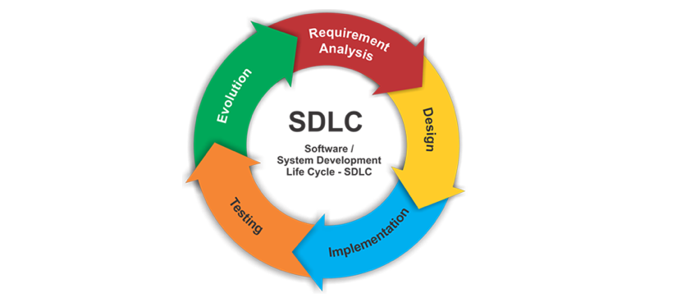It consists of various phases like requirement, feasibility study, design, coding, testing, installation and maintenance.

Figure 1.0 SDLC Diagram

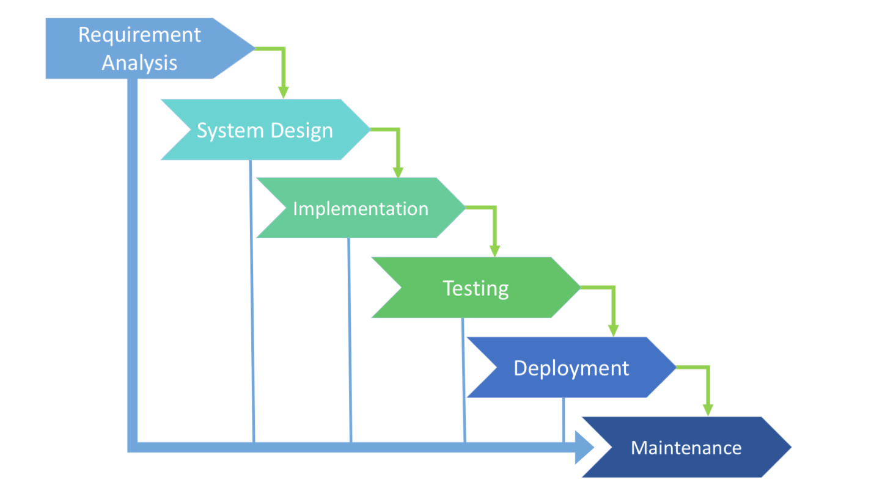

**Figure 1.1** SDLC Diagram using Water fall

### **Phase 1: Requirement collection and analysis**

In this phase mainly focus on gathering the business needs from the customer. Business Analyst collects the requirement from the customer and prepares the BRS (Business requirement Specification) which has the requirement in the business form. Then a group (BA, Project managers and customers) of people sits together and determines the requirements like; what should be input data to the system?  Who is going to use the system? What should be output data by the system?  These questions are getting answered during this phase. After this, a Requirement Specification document is created which gives the guideline for the upcoming phase of the model.

### **Phase 2: Feasibility study**

Once the BRS document is completed, a set of people like Human Resource department, Finance department, Business analyst, Architect and Project manager are sit together and analyze if the project is do able or not. This decision is taken based on the cost, time, resources and etc.

### **Phase 3: Design**

In this phase system design specification is prepared from the requirement document once the project is feasible, this design specification give input for the next phase of the model. Design is a blue print of the application and it helps in specifying hardware and requirements of the system and helps in defining architecture of the system.

### **Phase 4: Coding**

Once the system design document is ready, in this phase developer’s starts writing the code using any programming language i.e., they start developing the software. Generally task is divided in units or modules and assigned to the developers and this coding phase is the longest phase of SDLC.

### **Phase 5: Testing**

Once the software is ready and is deployed in the testing environment, test engineers starts testing, if the functionality of an application is working according to requirement or not. During this phase test engineers may encounter some bugs/defects which need to be sent to developers, the developers fix the bug and sent back to test engineers for testing. This process continuous until the software is bug free/stable/working according to the requirement.

### **Phase 6: Installation/Deployment**

Once the product developed, tested and works according to the requirement it is installed / deployed at customer place for their use.

### **Phase 7: Maintenance**

When the customers starts using the software they may face some issues and needs to be solved from time to time means need to fix those issue, tested and handed over back to the customer as soon as possible, which is done in the maintenance phase.

## **2.3 SDLC Models**

The models of SDLC are the methodologies that are selected for the software development is depending on the project’s aims and goals. These models are mainly used to develop software, based on the requirement, cost, customer and time, decide which model to be followed to develop software. Each model follows sequential steps of its own type, to develop high quality software.

The types of SDLC models are

* Waterfall Model
* Spiral Model
* Prototype Model
* V-Model
* Iterative model
* Agile Model

2.4 PROTOTYPE MODEL

In this Prototype Model before designing phase, a prototype is developed, tested, reviewed and approved by the customer, after that design will be ready for coding, testing, installation and maintenance will takes place. This prototype is prepared based on the customer requirements. Prototype testing is checking for the required components are present or not.

By using this prototype, customer can understand the requirements of desired system and also the customer can get an “actual feel” of the system. It is an attractive idea for complex and bigger systems.

In this Prototype Model before designing phase, a prototype is developed, tested, reviewed and approved by the customer, after that design will be ready for coding, testing, installation and maintenance will takes place. This prototype is prepared based on the customer requirements. Prototype testing is checking for the required components are present or not.

By using this prototype, customer can understand the requirements of desired system and also the customer can get an “actual feel” of the system. It is an attractive idea for complex and bigger systems.

During Prototyping model, the software development team, clarify requirements and/or design elements that generate mockups and prototypes of screens, reports, and processes. Although some of the prototypes may appear to be very substantial, they’re generally similar to a movie set: everything looks good from the front but there’s nothing in the back.

When a prototype is generated, the developer produces the minimum amount of code necessary to clarify the requirements or design elements under consideration. No effort is made to comply with coding standards, provide robust error management, or integrate with other database tables or modules. As a result, it is generally more expensive to retrofit a prototype with the necessary elements to produce a production module then it is to develop the module from scratch using the final system design document.

For these reasons, prototypes are never intended for business use, and are generally crippled in one way or another to prevent them from being mistakenly used as production modules by end-users

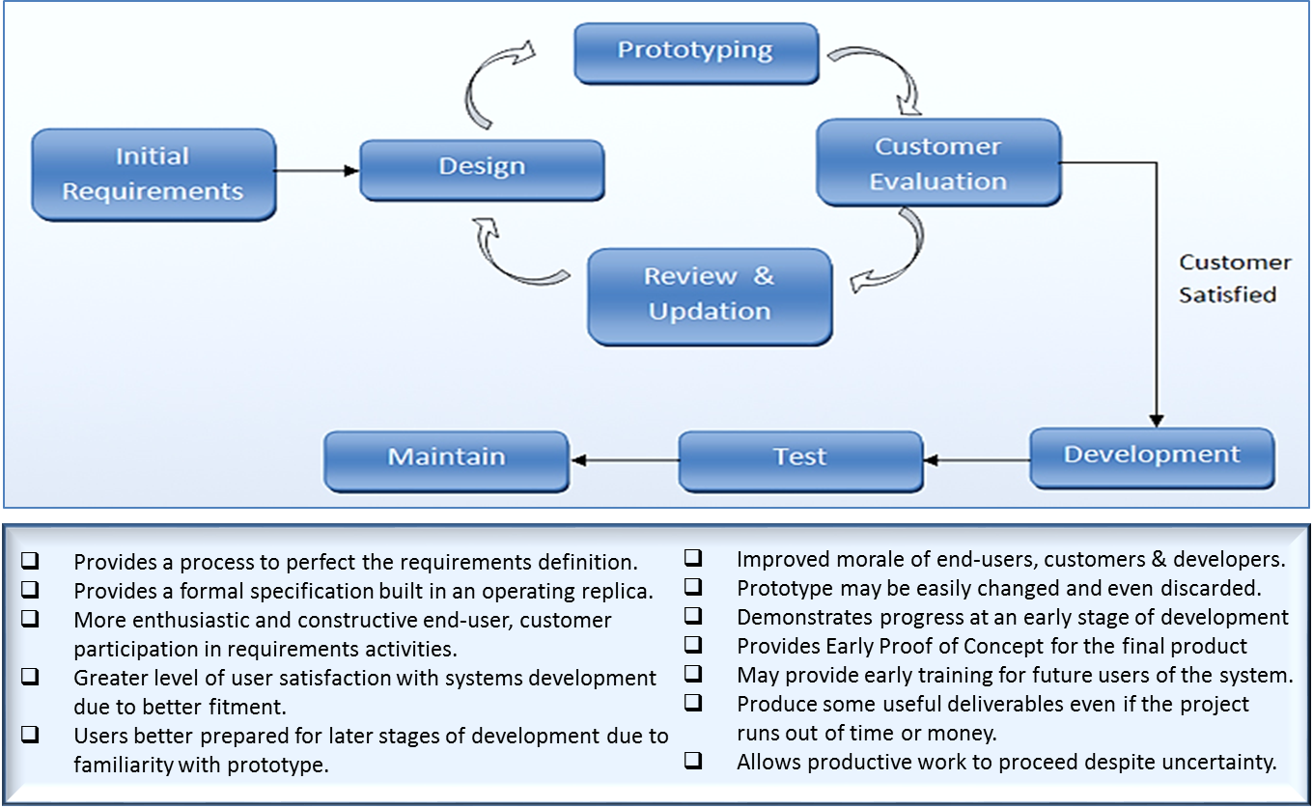

Figure 2.0 Prototype Diagram

This Prototype Model is same as waterfall model, but in this model we need to develop prototype and customer interaction will be there. Since there is customer interaction there will be less chance of rejection.

2.4.1 When to use Prototype model

* Whenever the customer not clears about the requirement in this situation we generally go for prototype model.
* If it is complex project then prototype model makes clear understand the requirement.
* Prototyping make sure that the customer constantly work with the system and provide a feedback about the system.
  + 1. Advantages of Prototype model
* Customer satisfaction exists, because customer can feel the product at very early stage.
* If there is missing functionality can be identified easily
* There will be less chance of software rejection.
* Requirement changes are allowed.
* Due to customer approval we can find the errors at early stage.
* Customer involvement will be there in the development where its leads to better solutions for any confusion / complexity / difficult functions
* The developed prototype can be re-used by developer and test engineer.
* The software designer and implementer can obtain feedback from the users early in the project.
* The client and the contractor can compare if the software made matches the software specification, according to which the software program is built.
  + 1. Disadvantages of Prototype model
* There are no parallel deliverables
* It is a time consuming if customer ask for changes in prototype
* This methodology may increase the system complexity as scope of the system may expand beyond original plans.
* The invested effort in the preparation of prototypes may be too much if not properly monitored.
* Customer may get confused in the prototypes and real systems.
  + 1. Application of prototype Model

1. The new system requirements are defined in as much detail as possible. This usually involves interviewing a number of users representing all the departments or aspects of the existing system.
2. A preliminary design is created for the new system.
3. A first prototype of the new system is constructed from the preliminary design. This is usually a scaled-down system, and represents an approximation of the characteristics of the final product.
4. The users thoroughly evaluate the first prototype, noting its strengths and weaknesses, what needs to be added, and what should to be removed. The developer collects and analyzes the remarks from the users.
5. The first prototype is modified, based on the comments supplied by the users, and a second prototype of the new system is constructed.
6. The second prototype is evaluated in the same manner as was the first prototype.
7. The preceding steps are iterated as many times as necessary, until the users are satisfied that the prototype represents the final product desired.
8. The final system is constructed, based on the final prototype.
9. The final system is thoroughly evaluated and tested. Routine maintenance is carried out on a continuing basis to prevent large-scale failures and to minimize downtime.

2.5 Design Documents

The Design phase requires the creation of several documents to save the documentation of the project. Two of those use case diagram and Data flow Diagram.

2.5.1 Use case Diagram

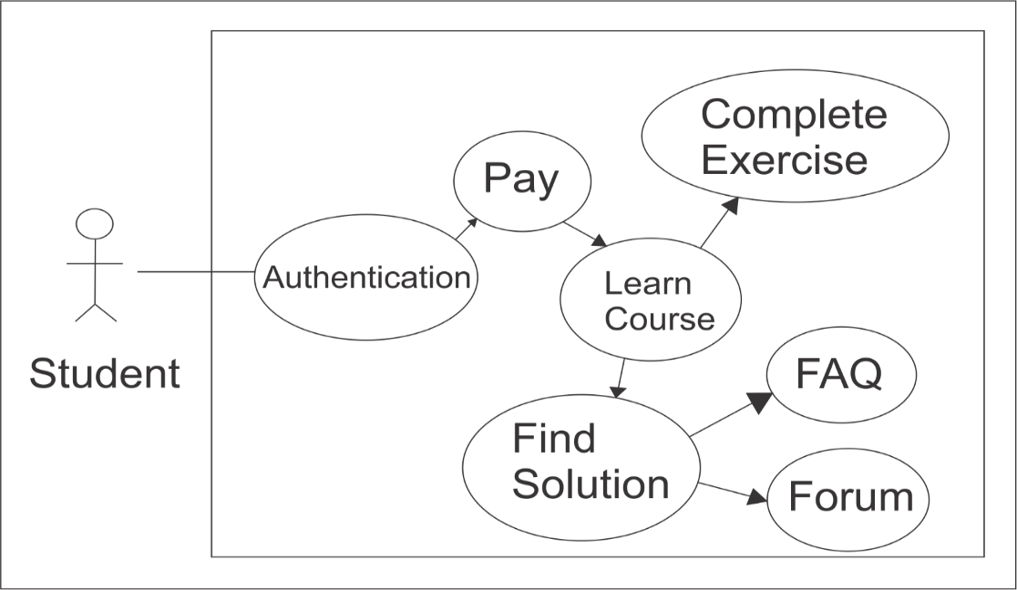A use case diagram at its simplest is a representation of a user’s interaction with the system that shows the relationship between the user and the different use cases in which the user is involved. It gives a very high level view of the system and is usually prepared before the development starts.

Figure 3.0 Use Case Diagram

From the diagram (Figure 1.0), we are able to see the interaction between the student and our system. Student must have to authenticate themselves via using register and login then the user must have to pay for his/her course fee after that the student can start learning the courses. During course various exercise student have to perform in order to complete the course .If The student face any problem during course then he/she can find solution form FAQ and Forum .If anyone wants to share knowledge the person can do this by using our forum community.

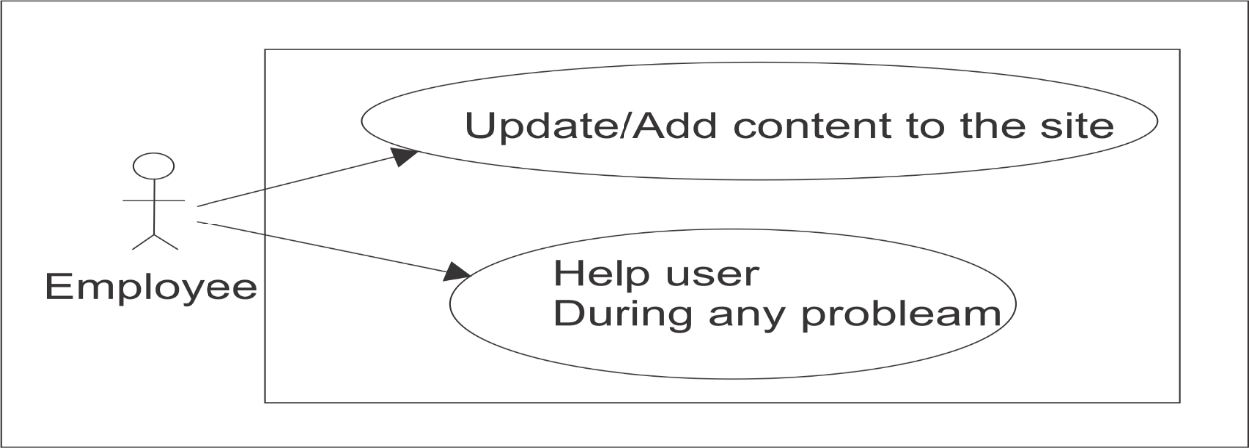

Figure 3.1 Use Case Diagram

In this (Figure 3.1) Diagram we can see the work mechanism of an employee. Hence an employee is a valuable person for our system that’s why employee have the ability to change/update and add content to our system. Employee also liable for giving response to the user during their problem.

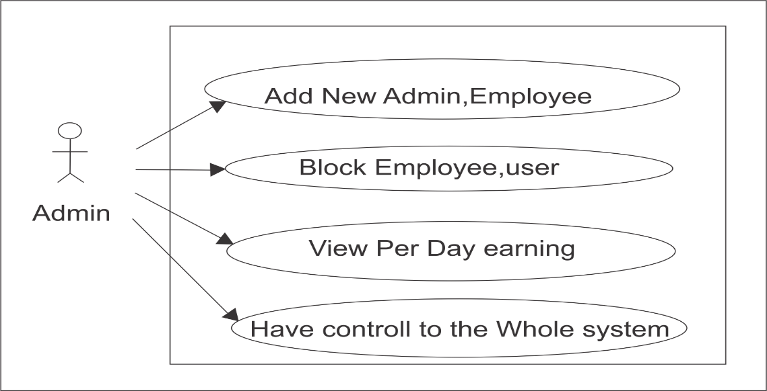

Figure 3.2 Use Case Diagram

Here the diagram(Figure 3.2) is giving us a brief idea of most liable person Admin and the liabilities hence admin is the owner of the system that’s why Admin have full control to the system, as well as Admin can do more than the normal user and the employee. Admin have the access to block an employee , add another person as admin and can see how much earning coming to the system daily, weekly, monthly and yearly.

2.5.2 Data Flow Diagram (DFD)

A data flow diagram (DFD) maps out the flow of information for any process or system. It uses defined symbols like rectangles, circles and arrows, plus short text labels, to show data inputs, outputs, storage points and the routes between each destination. Data flowcharts can range from simple, even hand-drawn process overviews, to in-depth, multi-level DFDs that dig progressively deeper into how the data is handled. They can be used to analyze an existing system or model a new one. Like all the best diagrams and charts, a DFD can often visually “say” things that would be hard to explain in words, and they work for both technical and nontechnical audiences, from developer to CEO. That’s why DFDs remain so popular after all these years. While they work well for data flow software and systems, they are less applicable nowadays to visualizing interactive, real-time or database-oriented software or systems.

A data flow diagram can dive into progressively more detail by using levels and layers, zeroing in on a particular piece.  DFD levels are numbered 0, 1 or 2, and occasionally go to even Level 3 or beyond. The necessary level of detail depends on the scope of what you are trying to accomplish.

2.5.2.1 LEVEL-0 or Context level Diagram

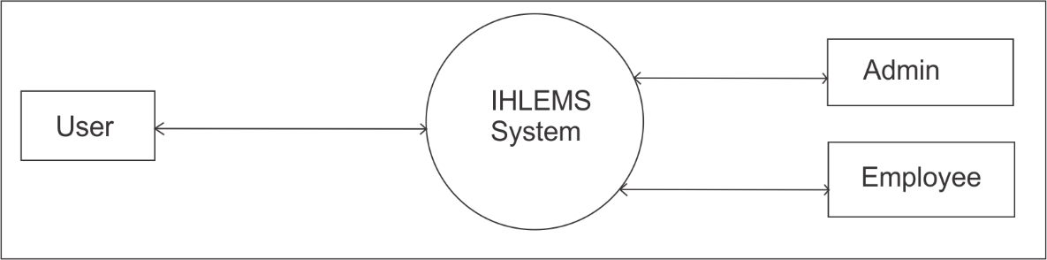DFD Level 0 is also called a Context Diagram. It’s a basic overview of the whole system or process being analyzed or modeled. It’s designed to be an at-a-glance view, showing the system as a single high-level process, with its relationship to external entities. It should be easily understood by a wide audience, including stakeholders, business analysts, data analysts and developers.

Figure 4.0 Context Level DFD / Level-0 Diagram

In this Diagram (fig 4.0) we can see or easily understand the data flow in our system .User is interacting with IHLEMS System as well as admin and Employee also interacting with the system for back side hence admin and employee panel will never appear in front of normal user.

2.5.2.2 LEVEL-1 Diagram

DFD Level 1 provides a more detailed breakout of pieces of the Context Level Diagram. You will highlight the main functions carried out by the system, as you break down the high-level process of the Context Diagram into its sub processes.

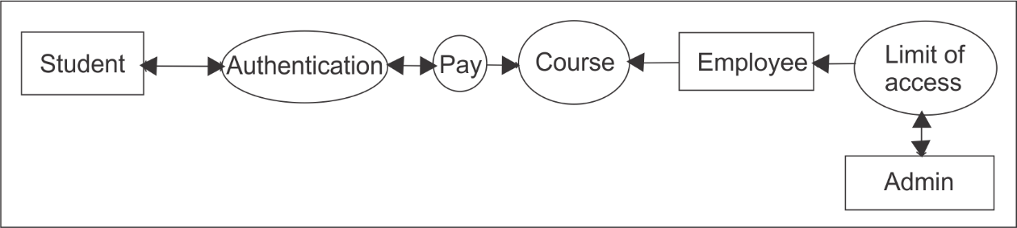

Figure 4.1 Level-1 Diagram

In this diagram (fig 4.1) we are able to see the interaction between student employee admin are break down into some sub processes. Now student have to authenticate before entering the system. Then the user must have to pay for his/her course fee after that the student can start learning the courses. Coerces can be altered by employee for determent and employee has some limit to access to interact with the system and the limitation is controlled by admin who is the owner of the system.

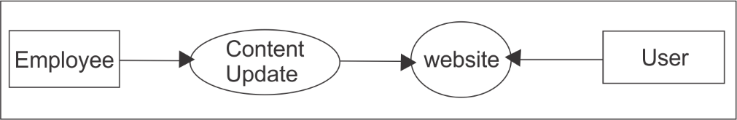

Figure 4.2 Level-1 Diagram

The diagram (fig 4.2) shows the interaction between the employee and the system. From the diagram we are able to see that employee can manipulate the content of the system or the website for betterment and ease of use.

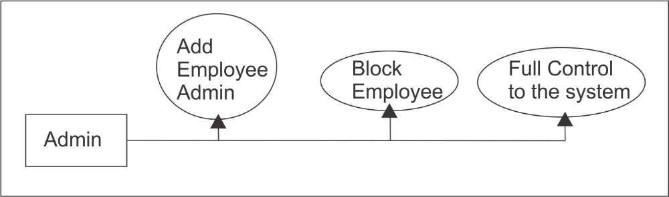

Figure 4.3 Level-1 Diagram

In this diagram (fig 3.4) shows the Admin interaction between the systems. Hence admin is the most liable person to the system that’s why Admin has full control the system also such as blocking an employee ad admin etc.

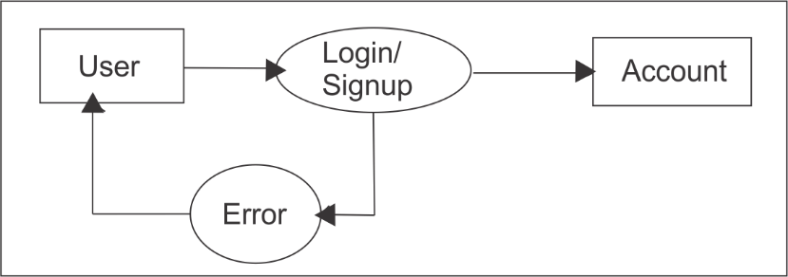

Figure 4.5 Level-1 Diagram

This diagram (fig 3.5) shows User authentication data flow between user and the system. IN order to enter user in our system new user must have to register Himself/herself via sign up process and existing user can login directly into the system. If error found during the sign up and login process then system will through error to the user.

2.5.2.3 LEVEL-2 Diagram:

DFD Level 2 then goes one step deeper into parts of Level 1. It may require more text to reach the necessary level of detail about the system’s functioning.

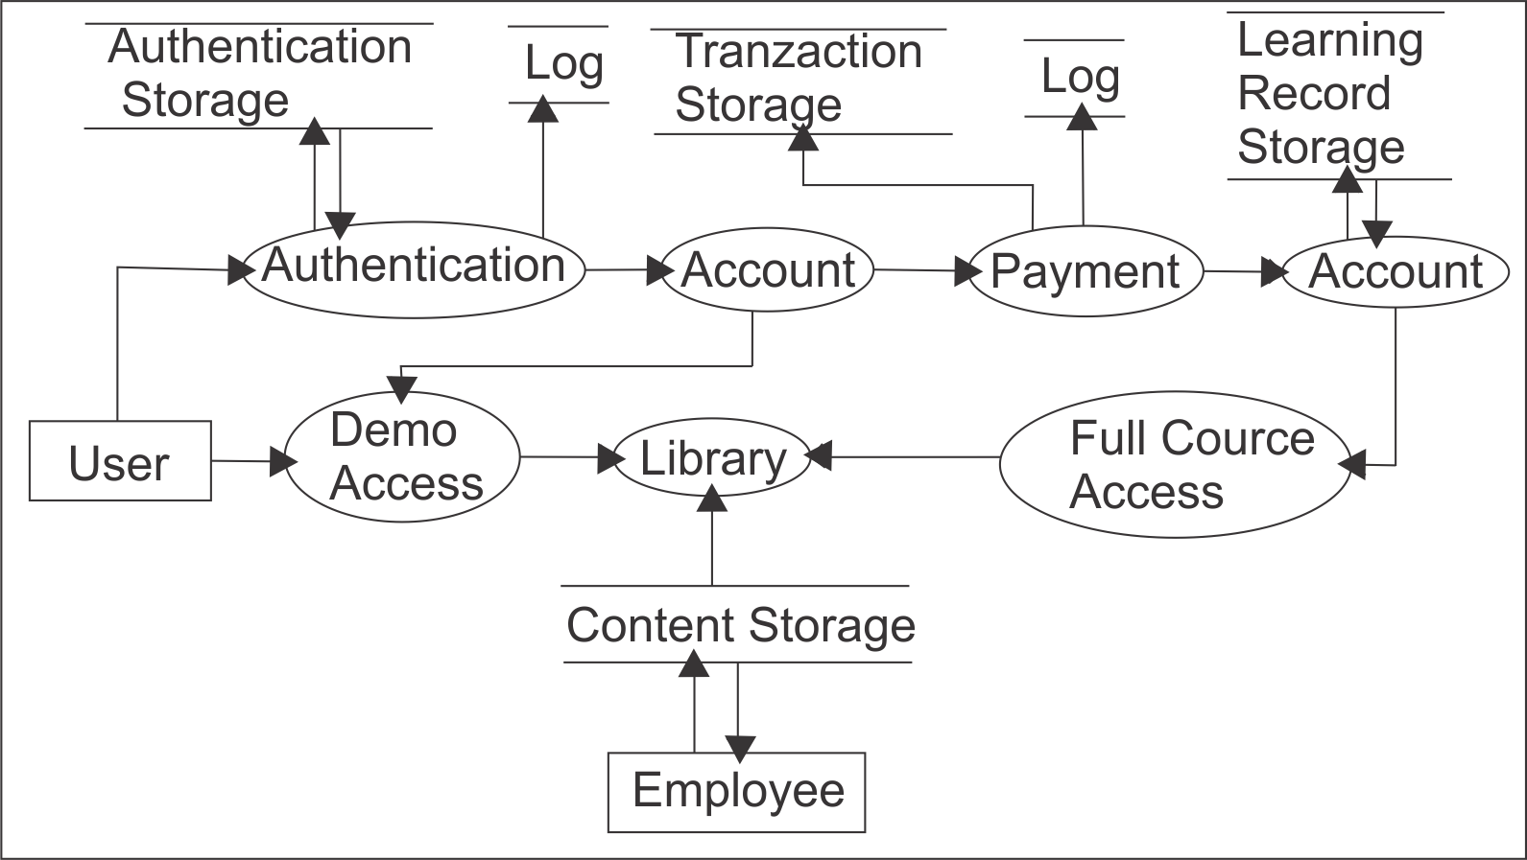

Figure 4.6 Level-2 Diagram

This diagram (Figure 4.6 ) is the elaboration of 1-level diagram here we can see that the More detailing of the system such as user have to authenticate in order to access some point of the system. And those data is store into Authentication storage. After that User will get his/her account then the user must have to pay for his/her course fee after that the student can start learning the courses and will get Full access to the library otherwise without authentication user can only access the demo version of the library. Payment Details will store into Transaction storage, learning record will store learning record storage and Coerces in the library is stored in Content storage which is controlled by Employee.

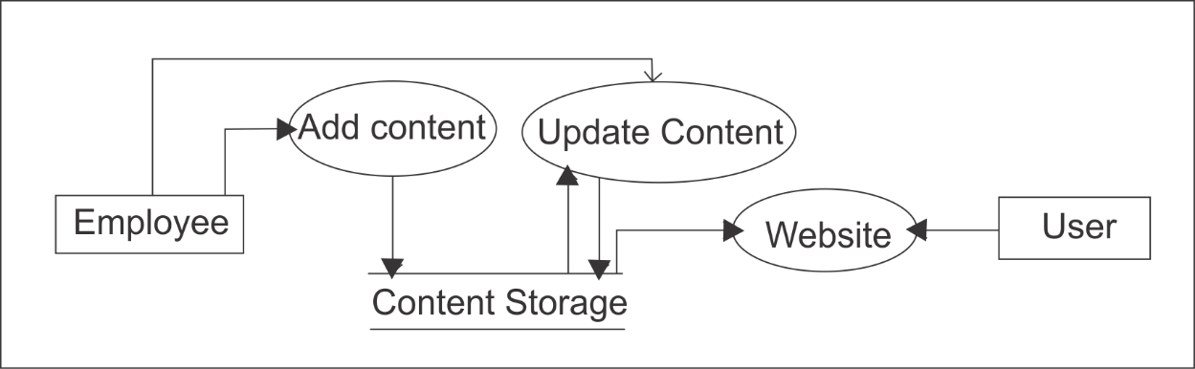

Figure 4.7 Level-2 Diagram

This diagram (Figure 4.6) is the elaboration of 1-level diagram here we can see that the More detailing of Employee area data flow now we are able to see Employee can add content and update the existing content or it can be deletion of an old content which all going into content Storage from where the Website contents are shown.

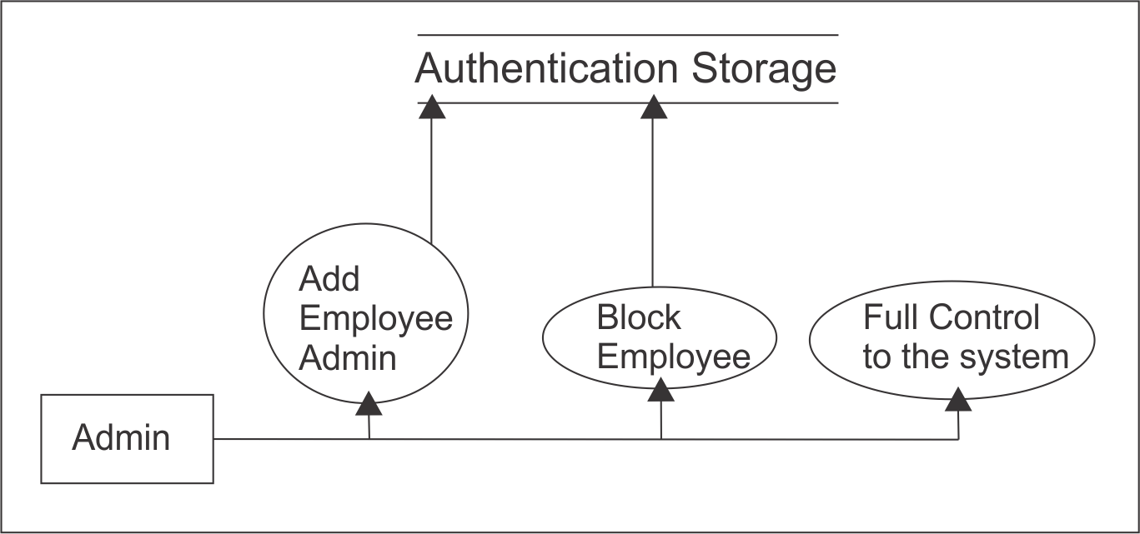

Figure 4.7 Level-2 Diagram

In this diagram we can see that the diagram is same as (fig 3.4) only this diagram (Figure 4.7) the extra component is Authentication storage which is for control someone activities such blocking employee user like that.

CHAPTER 3

**Tools and Environments Used**

**3.1 Tools / Platforms**

3.1.1 Front-end

* Web Technology: OOP PHP
* Languages Used: HTML,CSS,Jqery,Bootstrap,PHP
* Development Tool: Notepad ++, Atom, Xampp

3.1.2 Back end

* Database: MySQL Server
* Operating System: Windows 7 Ultimate
* Any Operating System compatible with WWW

3.1.3 Hardware Requirements

* Processor: Intel(R) Core(TM) i3-4030U CPU @1.90GHz 1.90GHz
* RAM: 4.00GB
* Hard Disk: 1.00TB
* System Type: 64-bit Operating System
* DVD Driver
* Peripherals like keyboard, Mouse, Printer
  1. Hardware Environment

Hardware Environment Like any good communicational software, a user interface is a two-way street. User don’t want to just see or hear what-ever the computer puts in front of them, They also wants to tell it what they would like to do. However everything they tells the computer is input and whatever the computer conveys to the user is output. On Interacting with computers an input and output devices used to communicate with users, and controls used to set preferences and make choices. A printer shall be used frequently. For this purpose, Dot Matrix/Inkjet printer is the minimum requirement. A line printer should prove to be more efficient. Authenticated Reports can be generated using a Laser Printer. The software shall be independent of printer type.

3.3 Software Environment

3.3.1 Xampp

Xampp is a free and open source cross-platform web server solution stack package developed by Apache Friends, consisting mainly of the Apache HTTP Server, Maria DB database, and interpreters for scripts written in the PHP and Perl programming languages. XAMPP stands for Cross-Platform (X), Apache (A), Maria DB (M), PHP (P) and Perl (P). It is a simple, lightweight Apache distribution that makes it extremely easy for developers to create a local web server for testing and deployment purposes. Everything needed to set up a web server – server application (Apache), database (Maria DB), and scripting language (PHP) – is included in an extractable file. XAMPP is also cross-platform, which means it works equally well on Linux, Mac and Windows. Since most actual web server deployments use the same components as XAMPP, it makes transitioning from a local test server to a live server.

3.3.2 Sublime text

Sublime Text is a proprietary cross-platform source code editor with a Python application programming interface (API). It natively supports many programming languages and markup languages, and functions can be added by users with plugins, typically community-built and maintained under free-software licenses.

3.3.3 Chrome

Google Chrome is a freeware web browser developed by Google. It was first released in September 2008, for Microsoft Windows, and was later ported to Linux, macOS, iOS and Android. Google Chrome is also the main component of Chrome OS, where it serves as a platform for running web apps.

3.3.4 Git

Git is a version control system for tracking changes in computer files and coordinating work on those files among multiple people. It is primarily used for source code management in software development but it can be used to keep track of changes in any set of files. As a distributed revision control system it is aimed at speed, data integrity, and support for distributed, non-linear workflows. Git was created by Linus Torvalds in 2005 for development of the Linux kernel, with other kernel developers contributing to its initial development. Its current maintainer since 2005 is Junior Hamano. As with most other distributed version control systems, and unlike most client–server systems, every Git directory on every computer is a full-fledged repository with complete history and full version tracking abilities, independent of network access or a central server.

3.3.5 Github

GitHub (originally known as Logical Awesome LLC) is a web-based hosting service for version control using git. It is mostly used for computer code. It offers all of the distributed version control and source code management (SCM) functionality of Git as well as adding its own features. It provides access control and several collaboration features such as bug tracking, feature requests, task management, and wikis for every project. GitHub offers plans for both private repositories and free accounts which are commonly used to host open-source software projects. As of April 2017, GitHub reports having almost 20 million users and 57 million repositories,making it the largest host of source code in the world.

* 1. Languages Used

3.3.1 HTML

Hypertext Markup Language (HTML) is the standard markup language for creating web pages and web applications. With Cascading Style Sheets (CSS) and JavaScript, it forms a triad of cornerstone technologies for the World Wide Web. Web browsers receive HTML documents from a web server or from local storage and render the documents into multimedia web pages. HTML describes the structure of a web page semantically and originally included cues for the appearance of the document.HTML elements are the building blocks of HTML pages. With HTML constructs, images and other objects such as interactive forms may be embedded into the rendered page. HTML provides a means to create structured documents by denoting structural semantics for text such as headings, paragraphs, lists, links, quotes and other items. HTML elements are delineated by *tags*, written using angle brackets. Tags such as <img /> and <input /> directly introduce content into the page. Other tags such as <p> surround and provide information about document text and may include other tags as sub-elements. Browsers do not display the HTML tags, but use them to interpret the content of the page.HTML can embed programs written in a scripting language such as JavaScript, which affects the behavior and content of web pages. Inclusion of CSS defines the look and layout of content. The World Wide Web Consortium (W3C), maintainer of both the HTML and the CSS standards, has encouraged the use of CSS over explicit presentational HTML since 1997.

3.3.2 CSS

Css is a style sheet language used for describing the presentation of a document written in a markup language like HTML. CSS is a cornerstone technology of the World Wide Web, alongside HTML and JavaScript.CSS is designed to enable the separation of presentation and content, including layout, colors, and fonts. This separation can improve content accessibility, provide more flexibility and control in the specification of presentation characteristics, enable multiple web pages to share formatting by specifying the relevant CSS in a separate .css file, and reduce complexity and repetition in the structural content. Separation of formatting and content also makes it feasible to present the same markup page in different styles for different rendering methods, such as on-screen, in print, by voice (via speech-based browser or screen reader), and on Braille-based tactile devices. CSS also has rules for alternate formatting if the content is accessed on a mobile device. The name *cascading* comes from the specified priority scheme to determine which style rule applies if more than one rule matches a particular element. This cascading priority scheme is predictable. The CSS specifications are maintained by the World Wide Web Consortium (W3C). Internet media type (MIME type) text/css is registered for use with CSS by RFC 2318 (March 1998). The W3C operates a free CSS validation service for CSS documents.

3.3.3 Bootstrap

Bootstrap is a free and open-source front-end library for designing websites and web applications. It contains HTML- and CSS-based design templates for typography, forms, buttons, navigation and other interface components, as well as optional JavaScript extensions. Unlike many web frameworks, it concerns itself with front-end development only. Bootstrap is the second most-starred project on GitHub, with more than 123,000 stars.

3.3.4 Jquery

JQuery is a cross-platform JavaScript library designed to simplify the client-side scripting of HTML. It is free, open-source software using the permissive MIT License. Web analysis indicates that it is the most widely deployed JavaScript library by a large margin. JQuery’s syntax is designed to make it easier to navigate a document, select DOM elements, create animations, handle events, and develop Ajax applications. JQuery also provides capabilities for developers to create plug-ins on top of the JavaScript library. This enables developers to create abstractions for low-level interaction and animation, advanced effects and high-level, theme able widgets. The modular approach to the jQuery library allows the creation of powerful dynamic web pages and Web applications.

3.3.5 Introduction to PHP

PHP started out as a small open source project that evolved as more and more people found out how useful it was. Rasmus Lerdorf unleashed the first version of PHP way back in 1994.

• PHP is a recursive acronym for "PHP: Hypertext Preprocessor".

• PHP is a server side scripting language that is embedded in HTML. It is used to manage dynamic content, databases, session tracking, even build entire ecommerce sites.

• It is integrated with a number of popular databases, including MySQL, PostgreSQL, Oracle, Sybase, Informix, and Microsoft SQL Server.

• PHP is pleasingly zippy in its execution, especially when compiled as an Apache module on the UNIX side. The MySQL server, once started, executes even very complex queries with huge result sets in record-setting time.

• PHP supports a large number of major protocols such as POP3, IMAP, and LDAP. PHP4 added support for Java and distributed object architectures (COM and CORBA), making n-tier development a possibility for the first time.

• PHP is forgiving: PHP language tries to be as forgiving as possible.

• PHP Syntax is C-Like.

3.3.6WhyRDBMS*?*

RDBMS approach is used for developing this project because it provides the minimum scope of data redundancy. Data redundancy is a very important factor which needs to be kept in mind. Redundant data may sometimes affect the efficiency of the whole system. Moreover there are various advantages of suing a RDBMS approach such that an important feature of relational systems is that a single database can be spread across several tables. This differs from flat-file databases, in which each database is self-contained in a single table. Other advantages are:

• Better techniques for data storage

• Less data retrieval time

• Better space management

• Scope of creating logical relationships among the entities

3.3.7 Introduction to MySQL

MySQL is a fast, easy-to-use RDBMS (relational database management systems) being used for many small and big businesses. MySQL is developed, marketed, and supported by MySQL AB, which is a Swedish company. MySQL is becoming so popular because of many good reasons:

• MySQL is released under an open-source license. So you have nothing to pay to use it.

• MySQL is very friendly to PHP, the most appreciated language for web development.

• MySQL is a very powerful program in its own right. It handles a large subset of the functionality of the most expensive and powerful database packages.

• MySQL uses a standard form of the well-known SQL data language.

• MySQL works on many operating systems and with many languages including PHP, PERL, C, C++, JAVA, etc.

• MySQL works very quickly and works well even with large data sets.

• MySQL is customizable

•Testing with git.

**CHAPTER 4**

**Database Design**

4.1 Introduction

Database design is the process of developing database structures to hold data to user requirements. The final design must satisfy user needs in terms of completeness, integrity, performance and other factors. For a large enterprise, the database design will turn out to be an extremely complex task leaving a lot to the skill and experience of the designer. A number of tools and techniques, including computer-assisted techniques, are available to facilitate database design.

The primary input to the database design process is the organizations’ statement of requirements. Poor definition of these requirements is a major cause of poor database design, resulting in databases of limited scope and utilities which are unable to adopt to changes.

The major step in database design is to identify the entities and relationships that reflect the organizations’ data, naturally. The objective of this step is to specify conceptual structure of the data and is often referred to as data modeling.

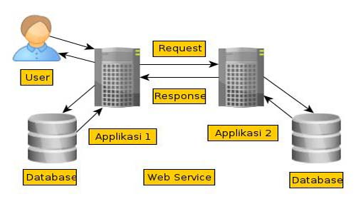There are several methodologies to model the data logically. We adopted ER modeling as our data modeling technique. ER model is technique

Figure 5.0 Database interaction

for analysis and logical modeling of systems data requirements. It uses three basic concepts: entities, attributes and relations.

4.2 Entity

Entity is a distinguishable object. These entities are classified into regular entities and weak entities. A weak entity is an entity that is existence dependent on some other entity i.e. it does not exist if that other entity does not exist. A regular entity is that it is not weak. The graphical notation of entity is shown below.

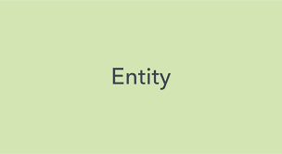 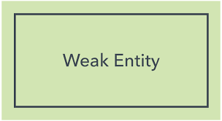

Figure 5.1 Entity Figure 5.2 Week Entity

4.3 Attribute

Entities have properties known as attributes. All entities of a given type have certain kinds of properties in common. Each kind of property draws its value from a corresponding value set. Properties can be of various types: Simple or composite, key, single or multi, missing, and base or derived. Attributes are graphically represented as shown below.

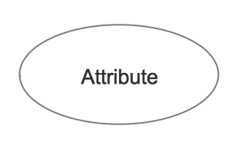

Figure 5.3 Attribute

4.4 Relationship

Relationship defines an association among entities. The entities involved in a given relationship are said to be participants in that relationship. The number of participants in a given relationship is called the degree of that relationship. An ER relationship can be one – one, one – many, and many - many. Cardinality of a relationship refers to representing the number of occurrences of entities in a given relationship. The graphical notation of relation is represented as shown below.

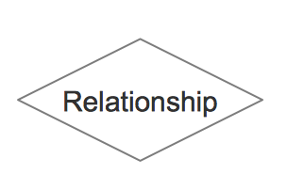 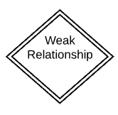

Figure 5.3 Relationship Figure 5.4 Week Relationship

In our project we have identified entities, attributes for those entities, and relationships between those entities from data collected at analysis phase.

4.5 Normalization

Normalization is the process of refining the data model built by the ER diagram. The normalization technique, logically groups the data over the number of tables, with minimum redundancy of data. The entities or tables resulting from normalization contain data items, with relationships being represented by replication of key data items. The goal of relational database design is to generate a set of relation schemes that allow us to store information with minimum redundancy of data and allow us to retrieve information easily and efficiently. The approach followed is to design schemas that are in an appropriate form one of the so-called normal form.

The first step towards normalization is to convert the ER model into tables or relations. The next step is to examine the database for redundancy and if necessary, change them to non-redundant forms. This non-redundant model is then converted into a database definition, which achieves the objective of the database design phase. We defined database from the above ER model by normalizing it to 3rd normal form. We will show the definitions of those database tables later at the time of physical database design phase.

4.5.1 1NF (First Normal Form)

First normal form (1NF) is a property of a relation in a relational database. A relation is in first normal form if and only if the domain of each attribute contains only atomic (indivisible) values, and the value of each attribute contains only a single value from that domain. The first definition of the term, in a 1971 conference paper by Edgar Codd, defined a relation to be in first normal form when none of its domains have any sets as elements. First normal form is an essential property of a relation in a relational database. Database normalization is the process of representing a database in terms of relations in standard normal forms, where first normal is a minimal requirement.

**First normal form enforces these criteria:**

* Eliminate repeating groups in individual tables.
* Create a separate table for each set of related data.
* Identify each set of related data with a primary key

4.5.2 2NF (Second Normal Form)

Second normal form (2NF) is a normal form used in database normalization. 2NF was originally defined by E.F. Codd in 1971. A relation that is in first normal form (1NF) must meet additional criteria if it is to qualify for second normal form. Specifically: a relation is in 2NF if it is in 1NF and no non-prime attribute is dependent on any proper subset of any candidate key of the relation. **A non-prime attribute of a relation** is an attribute that is not a part of any candidate key of the relation. Put simply, a relation is in 2NF if it is in 1NF and every non-prime attribute of the relation is dependent on the whole of every candidate key.

4.5.3 4NF (Boyce-coded normal form)

4NF is the next level of normalization after Boyce-Codd normal form Boyce–Codd (BCNF). Whereas the second, third and Boyce-codd normal forms are concerned with functional dependencies, 4NF is concerned with a more general type of dependency known as a multivalued dependency. A table is in 4NF if and only if, for every one of its non-trivial multivalued dependencies *X* ↠ {\displaystyle \twoheadrightarrow } *Y*, *X* is a super key—that is, *X* is either a candidate key or a superset thereof.

User account

|  |  |  |  |  |
| --- | --- | --- | --- | --- |
| User | | | | |
| uid | email | password | roll | Created-at |

|  |  |
| --- | --- |
| User_parameter | |
| Pram_id | parameter |

|  |  |  |  |  |
| --- | --- | --- | --- | --- |
| User-value | | | | |
| Uv-id | uid | Pram_id | value | Created_at |

4.5.4 3NF (Third Normal Form)

3NF is a normal form that is used in normalizing a database design to reduce the duplication of data and ensure referential integrity by ensuring that the entity is in second normal form, and all the attributes in a table are determined only by the candidate keys of that relation and not by any non-prime attributes. 3NF was designed to improve database processing while minimizing storage costs

Video

|  |  |  |  |  |  |
| --- | --- | --- | --- | --- | --- |
| Path | | | | | |
| Path_id | Name | Image path | Description | Published | Created_at |

|  |  |  |  |  |  |
| --- | --- | --- | --- | --- | --- |
| Cource | | | | | |
| cou_id | Path_id | Name | Image-path | Published | Created_at |

|  |  |  |  |  |
| --- | --- | --- | --- | --- |
| Content | | | | |
| cont_id | cou_id | Name | Published | Created_at |

|  |  |  |  |  |  |
| --- | --- | --- | --- | --- | --- |
| Video | | | | | |
| vid_id | cou_id | Name | Vid-path | Published | Created_at |

Student

|  |  |  |  |  |
| --- | --- | --- | --- | --- |
| Buy | | | | |
| B_id | Uid | Path-id | Name | Created_at |

|  |  |  |  |  |
| --- | --- | --- | --- | --- |
| watch | | | | |
| w_id | B_id | U_id | Vid_id | Created_at |

4.6 ERD & DB implementation

This is our System Integrated Hybrid Learning Earning System’s ER Diagram to illustrate the concept of our Database system.

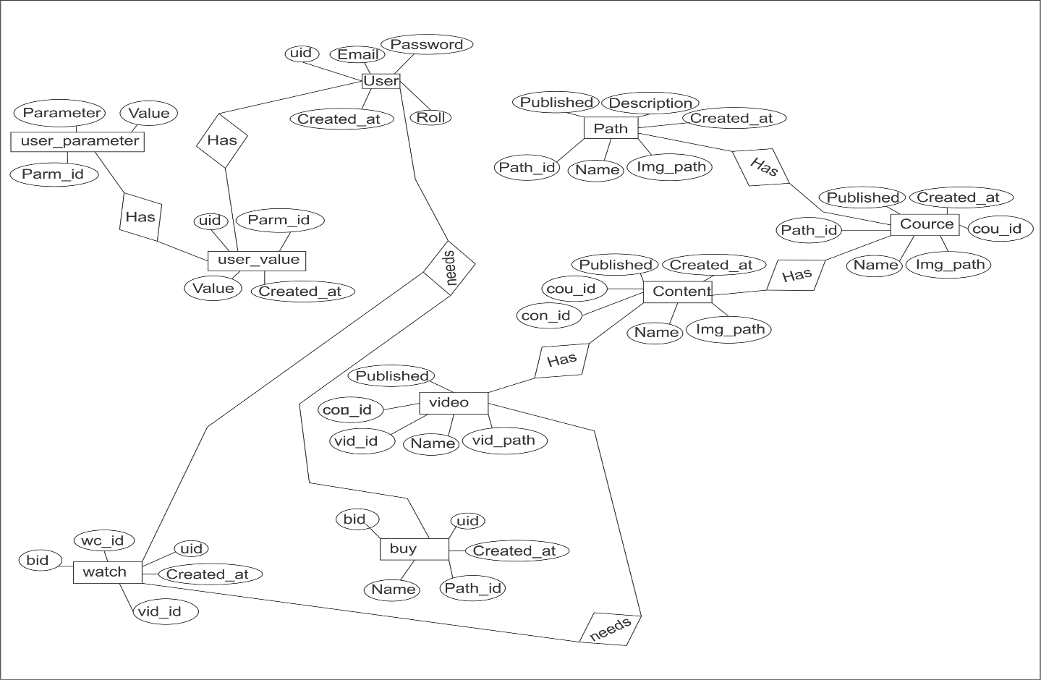

Figure 5.3 Entity Relationship Diagram ERD

CHAPTER-5

**Testing**

5.1 Introduction:

Software Testing is the process of executing a program or system with the intent of finding errors. Or, it involves any activity aimed at evaluating an attribute or capability of a program or system and determining that it meets its required results Software is not unlike other physical processes where inputs are received and outputs are produced. Where software differs is in the manner in which it fails. Most physical systems fail in a fixed set of ways. By contrast, software can fail in many bizarre ways. Detecting all of the different failure modes for software is generally infeasible unlike most physical systems; most of the defects in software are design errors, not manufacturing defects. Detecting all of the different failure modes for software is generally infeasible unlike most physical systems; most of the defects in software are design errors, not manufacturing defects. Because software and any digital systems are not continuous, testing boundary values are not sufficient to guarantee correctness. All the possible values need to be tested and verified, but complete testing is infeasible. Exhaustively testing a simple program to add only two integer inputs of 32-bits (yielding 2^64 distinct test cases) would take hundreds of years, even if tests were performed at a rate of thousands per second. Obviously, for a realistic software module, the complexity can be far beyond the example mentioned here. If inputs from the real world are involved, the problem will get worse, because timing and unpredictable environmental effects and human inter actions are all possible input parameters under consideration.

5.1.1 Purpose of testing software

* To carry out comprehensive testing of the system/product and its individual components in order to ensure that the developed system/product conforms to the user requirements/ design.
* To verify the proper integration of all components of the software.
* To verify that all requirements have been correctly implemented.
* To identify and ensure defects are addressed prior to the deployment of the software.

5.1.2 A test Plan must contain the following

• Scope of testing.

• Methodology to be used for testing.

• Types of tests to be carried out.

• Resource & system requirements.

• A tentative Test Schedule.

5.2 Testing Methods Used For Project

* + 1. Correctness testing

Correctness testing will need some type of oracle, to tell the right behavior from the wrong one. The tester may or may not know the inside details of the software module under test, e.g. control flow, data flow, etc. Therefore, either a white-box point of view or black-box point of view can be taken in testing software.

5.2.2 Black-box testing

The black-box approach is a testing method in which test data are derived from the specified functional requirements without regard to the final program structure it is also termed data-driven, input/output driven or requirements-based testing. Because only the functionality of the software module is of concern, black box testing also mainly refers to functional testing -- a testing method emphasized on executing the functions and examination of their input and output data. The tester treats the software under test as a black box – only the inputs, outputs and specification are visible and the functionality are determined by observing the outputs to corresponding Inputs. In testing, various inputs are exercised and the outputs are compared against specification to validate the correctness. All test cases are derived from the specification. No implementation details of the code are considered.

* + 1. White-box testing

A white-box, or glass-box in white-box testing, as the structure and flow of the software under test are visible to the tester. Testing plans are made according to the details of the software implementation, such as programming language, logic, and styles. Test cases are derived from the program structure. White-box testing is also called glass-box testing, logic-driven testing or design-based testing. There are many techniques available in white box testing, because the problem of intractability is eased by specific knowledge and attention on the structure of the software under test. The intention of exhausting some aspect of the software is still strong in white-box testing, and some Degree of exhaustion can be achieved, such as executing each line of code at least once (statement coverage), traverse every branch statements (branch coverage), or cover all the possible combinations of true and false condition predicates (Multiple condition coverage). Control-flow testing, loop testing, and dataflow testing, all maps the corresponding flow structure of the software into a directed graph. Test cases are carefully selected based on the criterion that all the nodes or paths are covered or traversed at least once. By doing so we may discover unnecessary "dead" code -- code that is of no use, or never get executed at all, which cannot be discovered by functional testing.

* + 1. Performance testing

Not all software systems have specifications on performance explicitly. But every system will have implicit performance requirements. The software should not take infinite time or infinite resource to execute. "Performance bugs" sometimes are used to refer to those design problems in software that cause the system performance to degrade. Performance has always been a great concern and a driving force of computer evolution. Performance evaluation of a software system usually includes: resource usage, throughput, and stimulus response time and queue lengths detailing the average or maximum number of tasks waiting to be serviced by selected resources. Typical resources that need to be considered include network bandwidth requirements, CPU cycles, disk space, disk access operations, and memory usage. The goal of performance testing can be Performance bottleneck identification, performance comparison and evaluation, etc. The typical method of doing performance testing is using a benchmark -- a program, workload or trace designed to be representative of the typical system usage.

* + 1. Reliability testing

Software reliability refers to the probability of failure-free operation of a system. It is related to many aspects of software, including the testing process. Directly estimating software reliability by quantifying its related factors can be difficult. Testing is an effective sampling method to measure software reliability. Guided by the operational profile, software testing (usually black-box testing) can be used to obtain failure data, and an estimation model can be further used to analyze the data to estimate the present reliability and predict future reliability. Therefore, based on the estimation, the developers can decide whether to release the software, and the users can decide whether to adopt and use the software. Risk of using software can also be assessed based on reliability information.

* + 1. Security testing

Software quality, reliability and security are tightly coupled. Intruders to open security holes can exploit flaws in software. With the development of the Internet, software security problems are becoming even more severe. Many critical software applications and services have integrated security measures against malicious attacks.

5.3 Demonstration

5.3.1 Home page

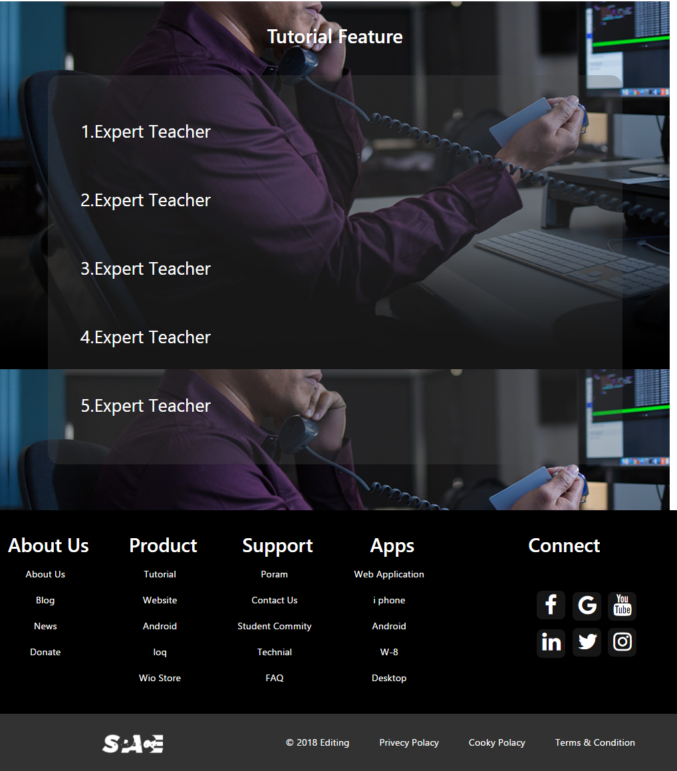

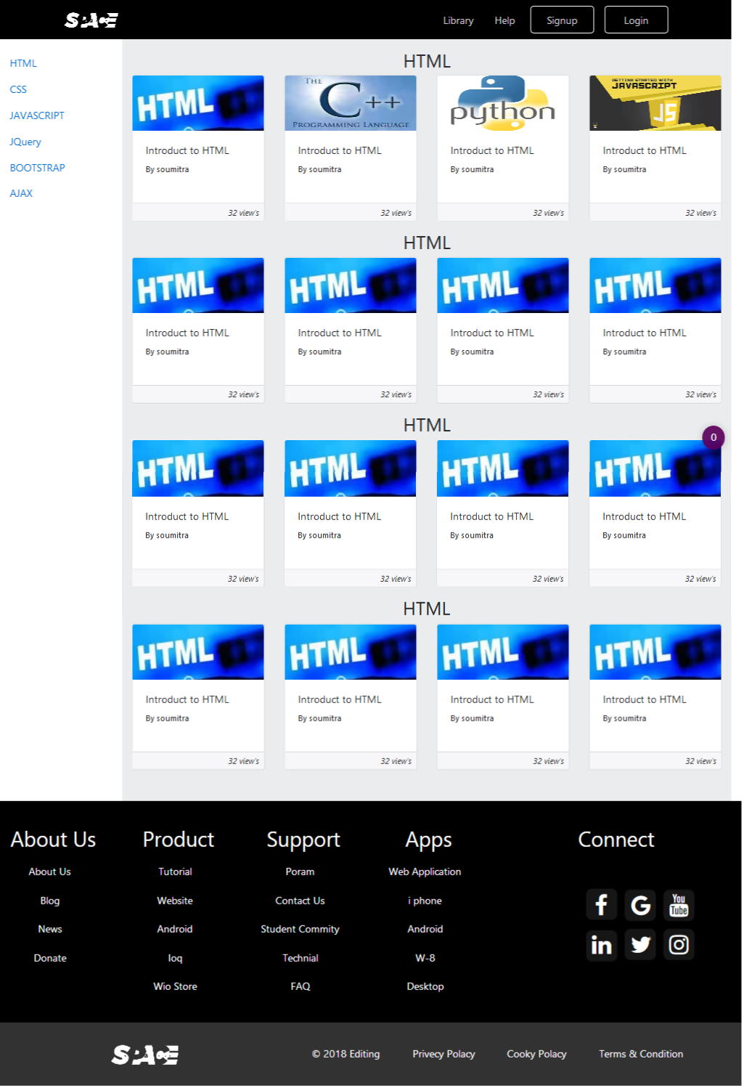5.3.2 Library

5.3.3 Login

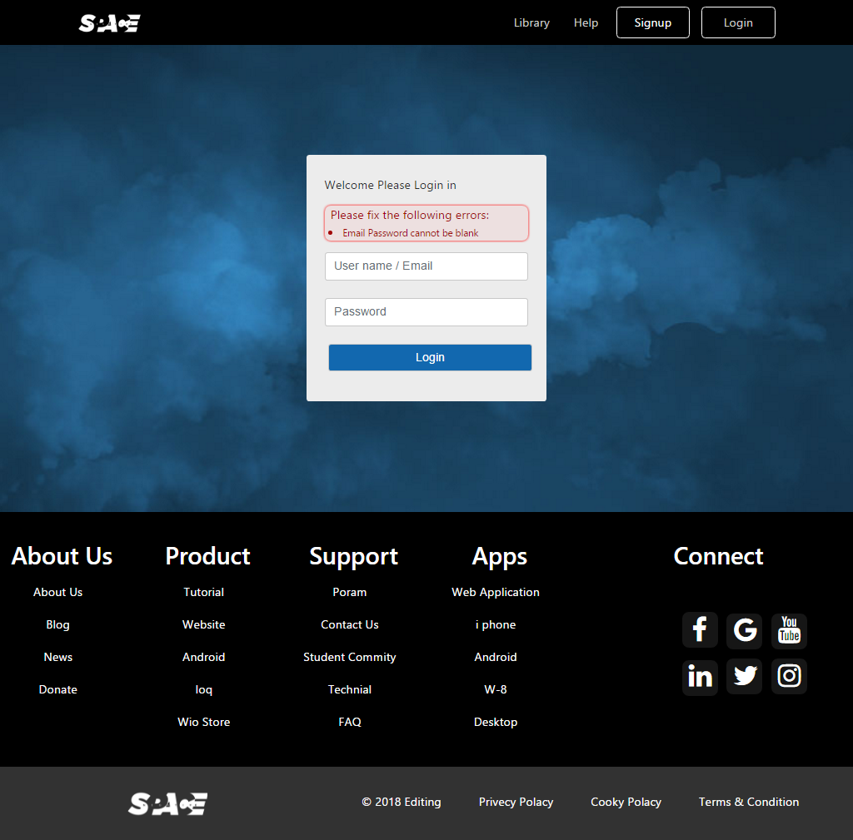

5.3.4 Signup

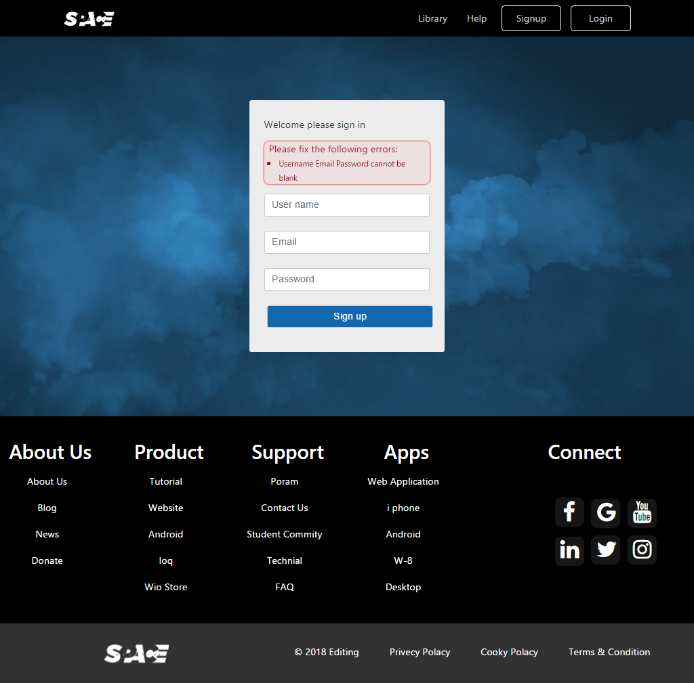

5.3.5 employee aera

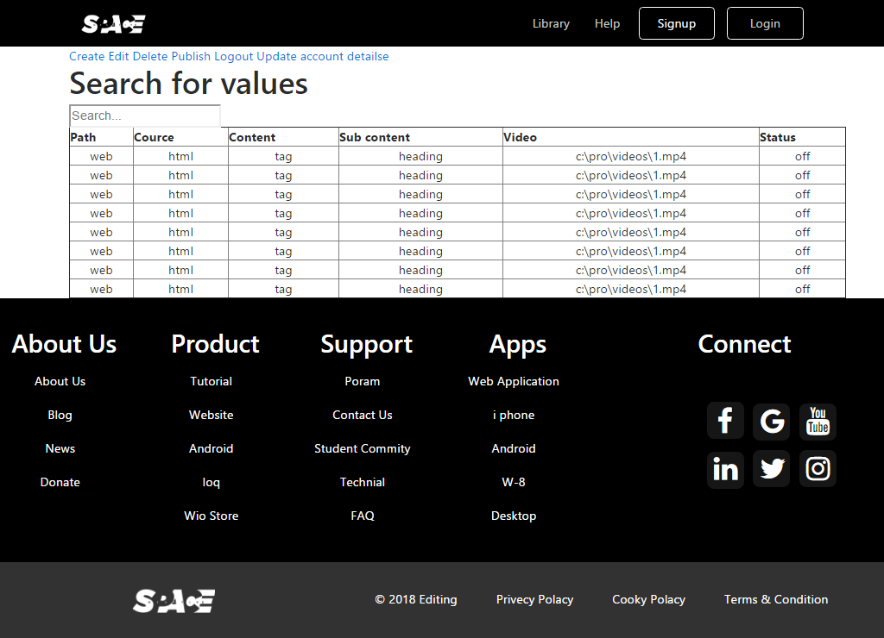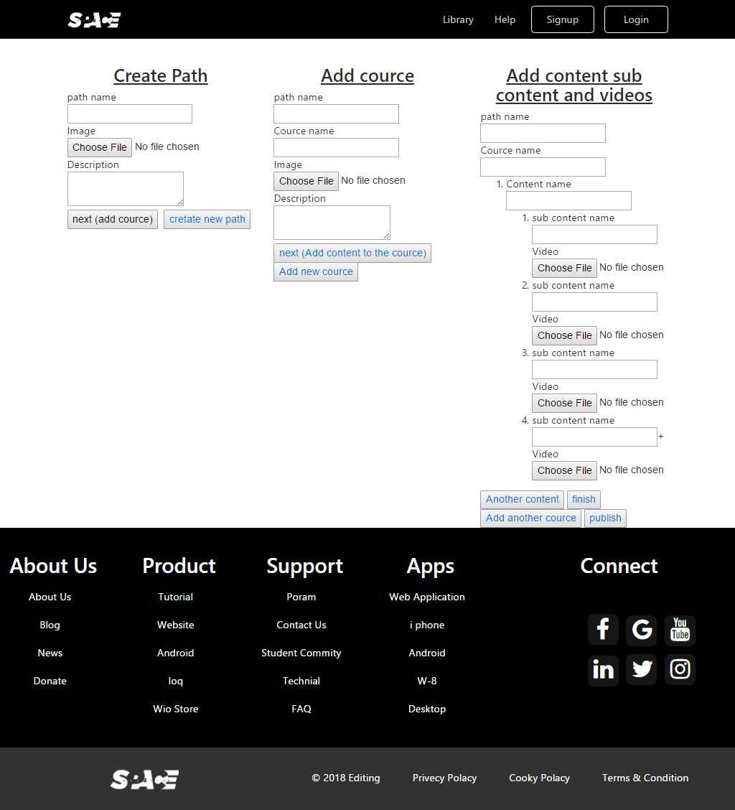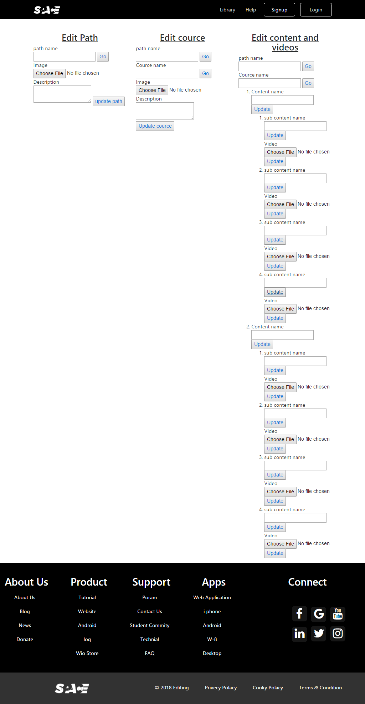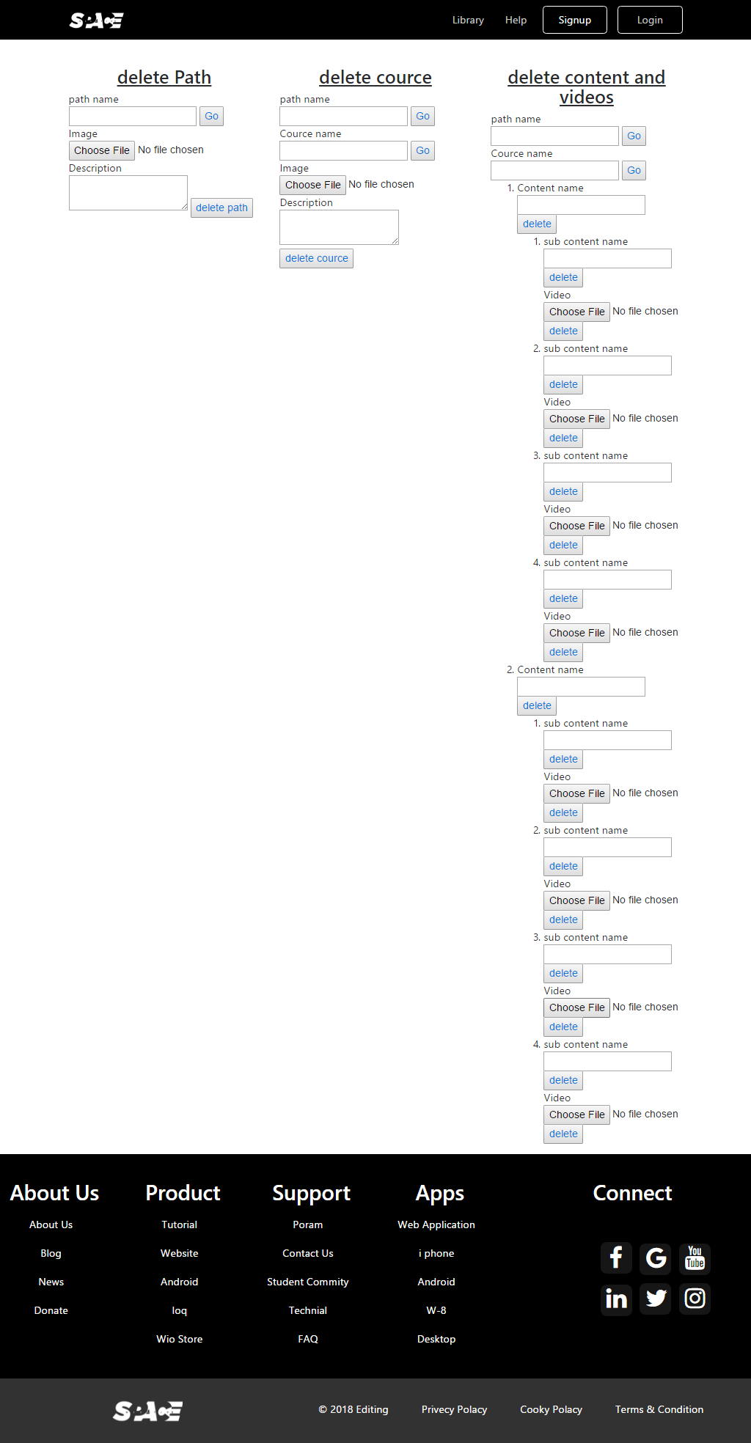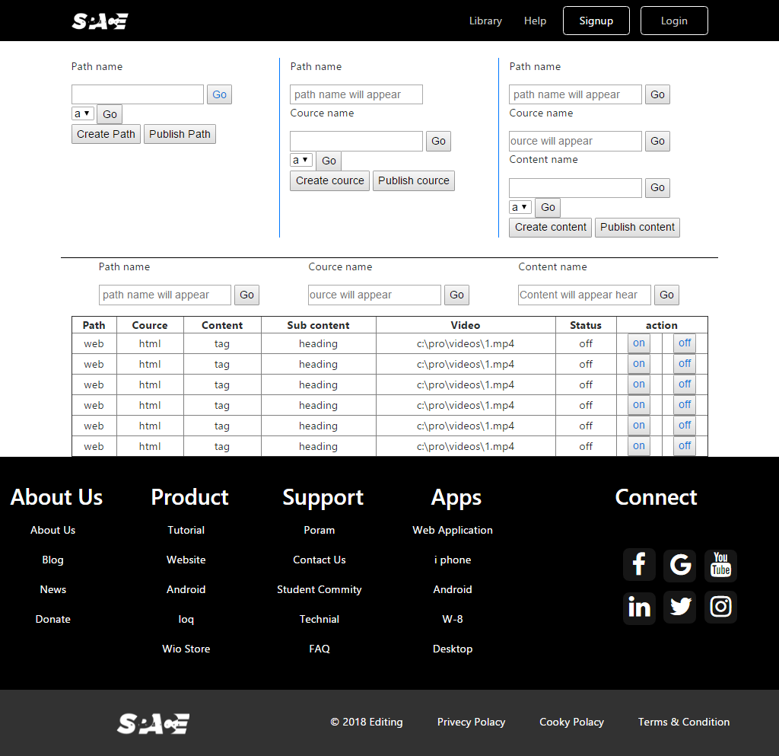

**CHAPTER-6**

**Development schedule**

Development schedule is one of the important part of the planning, there are different way of making development here we used Gantt chart for development schedule. The development schedule must be independent as possible. Ideally the components should be stand-alone so that it does not need any other component to operate. This is only possible for every simple component and more complex component is inevitably having some dependencies on other component. The schedule gives the time estimation of the project. In the project or development of software there are different phases like study, design, implementation and test. Our project also has different phases and each phase takes different time for development. Our project starts from 22/03/2018 and ends on 22/05/201. The total time taken by our project is 8 weeks. The project consists of different phases like Analysis, design, implementation and testing

* 1. Total Project time
* Analysis – 7 days (22/03/2018 – 29/03/2018)
* Design – 7 days (29/03/2018 – 06/04/2018)
* Implementation – 25 days (06/04/2018 – 30/04/2018)
* Testing – 7 days (30/04/2018 – 07/05/201)
* Deployment – 15 days (07/05/2018 – 22/05/2018)

**CHAPTER-7**

**CONCLUSION**

From the above discussion we conclude that e-learning is an innovative technique from Integrated Hybrid Learning Earning Management System used in providing learning experiences to the students on-line through the use of Internet services and Web technology of computers on the same lines as witnessed by us in the form of e-mail, e-banking, e-booking and e-commerce in our day-to-day life. E-Learning is also having some disadvantages which are discussed earlier.

Inspire of certain defect, e-Learning is very useful and it is becoming more and more popular.

* Integrated Hybrid Learning Earning Management System bring with it new dimensions in education. Many of the unique features of e-Learning. The project have a smart way to learning courses the user feel a friendly environment anywhere & any time.
* Opening up border education option 24/7 accessibility makes scheduling easy and allows a greater number of people to attend classes’ on-demand access mean learning programs.